**SUMMER EXHIBITION 2021 PRESS IMAGE CAPTIONS**

**Terms and Conditions**

* Images supplied are for use only in connection with ‘*Summer Exhibition 2022’*,Royal Academy of Arts, 21 June – 21 August 2022
* Images are only reproduced to illustrate a review or criticism of a work or report as defined by section 30 (i) and (ii) of the Copyright, Designs and Patents Act 1988.
* All image reproductions must credit the artist, title of the work, date of work and be accompanied by credit lines as provided by the Royal Academy of Arts.
* Images must be reproduced in full with no cropping, overprinting or be subjected to any form of manipulation without prior written permission of the copyright owner and the owner of the work.
* Use of images on front and back covers require prior written permission of the copyright owner and owner of the work and may attract a fee. Please contact Royal Academy of Arts Press Office.
* Images are for your own use only and must not be transferred to any third-parties.
* Images supplied are for one time use only and must not be stored on a database.

For further information, please contact Royal Academy of Arts Press Office: 020 7300 5615 or email [**press.office@royalacademy.org.uk**](mailto:press.office@royalacademy.org.uk)

Amy Shelton,

*Herald of Spring*

Pressed vascular wild plants, LED light box, 131 x 81 x 7 cm

Photo: Senecio for RAMM

Kathleen Ryan

*Bad Lemon (Josh)*

Aventurine, serpentine, agate, quartz, Ching Hai jade, red malachite, hematite, jasper, rose quartz, carelian, onyx, mother of pearl, freshwater pearl, bone, acrylic, glass, stell pins on coated polystyrene, 49 x 79 x 49 cm

Courtesy of the artist and Josh Lilley

Alison Wilding OBE RA

*Arcadia*

Digital print with hand finishing, 64.5 x 86 cm

Redbreast Editions

Ben Edge

*Man Made Nature*

Synthetic flowers, sports trainers on plastic mannequins, 196 x 122 x 61 cm

Photo: © Sylvie Tata

Clara Hastrup

*Diver*

Digital inkjet print on semi-gloss paper, 59.4 x 42 cm

Courtesy of the artist

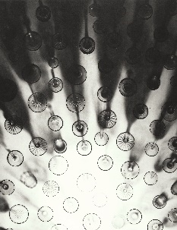

Cornelia Parker OBE RA

*Sunrise*

Polymer gravure etching on Hahnemühle print making board 300 gsm, 72.5 x 56.4 cm

Courtesy artist and Cristea Roberts Gallery, London

Gavin Turk

*Enigma*

Photograph printed on dichroic glass, 100 x 100 x 30 cm

Courtesy of the artist

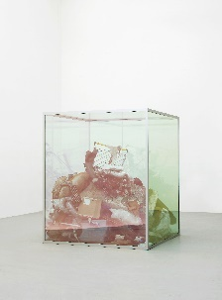Gavin Turk

*Looking Glass*

Glass and mixed media, 2000 x 1700 x 1700 cm

Courtesy of the artist

Jim Dine Hon RA

*Banjo Plays, Battleship, Maine*

Woodcut in black with hand painting in red acrylic on Japanese paper , 133 x 101.7 cm

Courtesy artist and Cristea Roberts Gallery, London

Liane Lang

*Quarry Road*

Mixed media on tarmac road, 40 x 36 x 10 cm

Timo Aho & Pekka Niittyvirta

*Lines (57° 59′ N, 7° 16’W)*

Photo: Pekka Niittyvirta

Rasheed Araeen

*Vertical Structure with Two Diamonds*, 2018

Acrylic on wood, 182 x 48 x 8 cm

Courtesy of Grosvenor Gallery

Singh Twins

*Because You're Worth It? II (Slaves of Fashion Series)*

Digital dyed fabric lightbox, 180 x 180 x 6.65 cm

Photo: © The Singh Twins: [www.singhtwins.co.uk](http://www.singhtwins.co.uk)

Vanessa Jackson RA

*Rotate V*

Oil on canvas, 50 x 40 cm

Courtesy of the artist

Yinka Shonibare CBE RA

*Modern Magic V, From: Modern Magic*

Relief print with woodblock and fabric collage on Somerset tub sized satin radiant white 410 gsm paper, 84 x 62 cm

Courtesy artist and Cristea Roberts Gallery, London